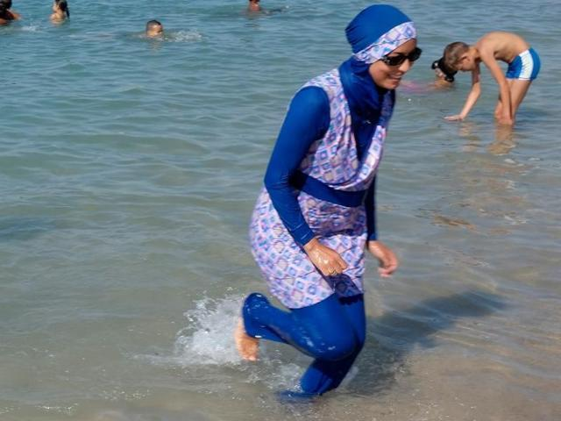
France’s burkini debate: About a bathing suit and a country’s peculiar secularism
By James McAuley
August 26, 2016

PARIS — France’s highest administrative court on Friday overturned a ban on burkinis in a coastal area of the south of France, capping a month of intense national scandal and international outrage.

Intellectual, elite class
In the last month, more than two dozen French cities and towns have outlawed the full-bodied swimsuit — designed for Muslim women to enjoy the beach while still observing traditional codes of modesty. Local governments had imposed the bans in the name of secularism because, for some, the burkini seemed an unwelcome display of religion threatening the basic French ideals of liberty, equality and fraternity.
But for many French Muslims and members of France’s intelligentsia, the bans sparked an instant outrage over an unnecessary crackdown on a nonexistent problem. The same was true for millions of international observers, especially after images surfaced this week of a French police squadron surrounding a Muslim woman sunbathing on a beach in Nice, demanding that she remove portions of her clothing in broad daylight.

To anger

To bring under control
Male dominated

Non-religious

Fundamental belief
The French court ultimately agreed — calling burkini bans an insult to “fundamental freedoms” such as “the freedom of conscience and personal liberty.” And yet a significant majority of the French do not view the bans as a problem.
According to a poll released this week by the survey firm IFOP, 64 percent approve of the state policing what Muslim women wear to the beach. Likewise, most of France’s major politicians — conservative and liberal — seem to agree that the burkini has no place in their county.
For those on the right, including former president Nicolas Sarkozy, the burkini is a “provocation,” a symbol of radical Islam in a country still reeling from the terrorist attacks in Paris last fall and in Nice in July. For those on the left, such as Prime Minister Manuel Valls, the burkini is a means of “enslavement,” the subjugation of women to a patriarchal religion.
But these different objections to the burkini are rooted in the same soil: France’s unique — some would say bizarre — ideology of secularism.
Ever since the French Revolution of 1789, France has aspired to an ideal of secular democracy completely free from the influence of any church or creed. By 1905, toward the conclusion of the Dreyfus affair, when a Jewish army captain was falsely accused of spying, church and state were officially separated by law.
But in France, that type of secularism, which is common in countries around the world, soon became a creed in its own right. The initial prohibition against the state — or any of its representatives — showing religious preference eventually became a prohibition against private citizens showing any religious preference in public.

Dress for Muslim women that involves full coverage

Focal point of activity

supporters

For many, the burkini — like the headscarf and the burqa before it — is seen as precisely that kind of public religious expression, decidedly unwelcome in a universalist republic of equal citizens.
Christian Estrosi, an outspoken supporter of the burkini ban who runs the Provence-Alpes Côte d’Azur regional council, sharply criticized the court’s Friday decision.
“Public space is a place where everyone, without discrimination, can be a free citizen,” he said in a statement. “Wearing an outfit that fully covers the body to go to a beach does not correspond to our vision of living together, particularly with regard to the equality of men and women.”
In a country that prides itself as an epicenter of world fashion, what women wear has never been without cultural and political significance. But in recent decades, it is the Muslim women of France who have garnered the most scrutiny with regard to their clothes.
In 2004, in another epic controversy, France passed a law banning the hijab — the headscarf — in public schools; in 2010, it became the first European country to ban the face-covering burqa outright. In both cases, advocates of the bans argued that prohibiting these garments ensured a public sphere where all citizens could be free — from religion, but also from the choice they may make themselves.
Muslims see these bans — and especially the recent ban on the burkini — as little but thinly veiled institutionalized Islamophobia in a country that is home to one of the largest Muslim populations in Europe.
Marwan Muhammad, the director of the Collective Against Islamophobia in France, one of the nongovernmental organizations involved in challenging the burkini ban, called Friday’s decision a “huge victory for human rights in France.”

real

The main victory, he said, was political. “The courts will not give into political Islamophobia,” he said in an interview. “There are a number of judges that will affirm the rule of law. We are able to protect and defend human rights.”
Yet the burkini is not the same as the burqa or the hijab: The objections to this particular bathing suit cannot all be explained by a certain interpretation of conservative values.
Unlike the bans on the other Muslim garments, the burkini bans emerged in the immediate aftermath of the recent terror attacks — and, notably, in the same region that the Nice attack had targeted. In that attack, a Tunisian resident of the Mediterranean city killed 86 and injured hundreds in a murderous truck rampage down the city’s famous seaside boulevard.
For Joan Wallach Scott, a leading expert on French secularism and the author of “The Politics of the Veil,” the burkini ban is an unmistakable response to terrorism.
“What’s happening right now is a displacement of the anxiety after the attacks last fall and then in Nice,” she said in an interview. “It’s a displacement of the anxiety about security, and the sense that nothing can be done to protect anyone.”
“In a sense, it’s a local government showing that it can do something to deal with terrorism. It’s an absurd connection, but it locates a threat in a concrete and tangible way.”
The city of Nice — where Estrosi was formerly mayor — made the connection between the burkini and terrorism explicit. The swimsuit had to be banned because, in Estrosi’s words, it “overtly manifests adherence to a religion at a time when France and places of worship are the target of terrorist attacks.”

Obvious
Shows, support

Subordinate, subject to higher authority

Outwardly appearing, pretending

Isolated

including

Estrosi’s office declined to provide further comment on Friday afternoon.
For Scott, the greatest irony in the entire affair is that the burkini in fact embodies the achievement of a secular, integrated society.
The women who wear burkinis, she said, cannot be called oppressed. They are not the women subservient to a conservative Islam; they are the women who sit on beaches unsupervised by men, enjoying their leisure time in mixed social company.
But because of the same type of secularism ostensibly designed to foster equality among citizens, those same women could in fact be driven further from the social mainstream.
“It just convinces Muslims who are already feeling discrimination and alienation that indeed they’re right,” Scott said. “And that the French government is interested in getting rid of them, not in integrating them.”

