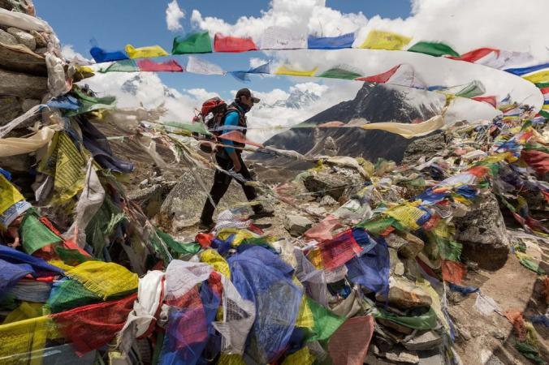

Sherpas: The Invisible Men of Everest

They carry the heaviest loads and pay the highest prices on the world's tallest mountain.

By Chip Brown,
National Geographic

PUBLISHED April 26, 2014
Sherpas working on Everest normally don't die en masse. Apart from their darkest seasons—1922, 1970, and now, 2014, the darkest of all—they tend to perish one by one, casualties of crevasse falls, avalanches, and altitude sickness. Some have simply disappeared on the mountain, never to be seen again.
If mentioned at all, their individual deaths are briefly noted in the Western media. Last year, when the attention of the world was focused on a fight between Sherpas and some Western mountaineers, you would hardly have known four Sherpas died on Everest in separate incidents. Likewise, the year before: three more Sherpa fatalities.
The sad fact is that over the years Sherpas and Nepali mountain workers have died so routinely—40 percent of all Everest deaths over the last century—that it's easy for Western tourists and guiding agencies, Nepali officials, and even some Sherpas themselves to gloss over the loss of any one particular life. Sincere condolences are offered. Inadequate insurance payments are made. Chortens are built, plaques affixed, pictures posted on blogs. And then all parties turn back to the mighty Everest cash machine and the booming business of catering to thousands of foreigners paying small fortunes to stand on the top of the world...
Culture of Mountaineering
These are times of crucial change for Sherpa culture, and in particular for the subculture of the Sherpa climbing community. Since Sherpas first were hired away from their potato farms to carry loads for an expedition in 1907, Sherpa culture has arguably been more influenced by the Western passion for mountaineering than by any other single force.
In less than a century, they have come from wondering about the sanity of the mikaru, their term for foreign climbers, to being among the best mountaineers in the world themselves. Sherpas hold speed records on Everest. They work as guides on Denali and Mount Rainier. In 2012, Mingma and Chhang Dawa Sherpa of Seven Summit Treks became the first two brothers to climb all 14 of the world's 8,000-meter (26,000-foot) peaks.
It's hard to imagine that the Sherpa porters on the British expeditions to the Tibet side of Everest in the 1920s did not even have a word for "summit." Instead, they were convinced, as Wade Davis notes in his book Into the Silence: The Great War, Mallory, and the Conquest of Everest, that the foreigners were treasure hunters searching for a statue of a golden cow or yak to melt down for coins.
In 1950, American mountaineer Charles Houston was a member of the first team of Westerners to explore Everest from the south. He photographed Namche Bazaar, the so-called Sherpa capital, which at the time was a small, profoundly isolated village of slate-roofed stone houses. No hydropower, no four-story hotels, no dental clinic, no gear shops stuffed with counterfeit North Face fleece, no coffeehouses with Internet access.
Most Sherpas spoke only their own language and had little contact with the world beyond the mountains. The transformation began when the Sherpa–New Zealander duo of Tenzing Norgay and Edmund Hillary scaled Everest in 1953. Much of the credit for how life in Khumbu has improved is owed to Hillary, esteemed until his death in 2008 as "the Sherpa King" for his efforts to build schools and health clinics and raise living standards.
Steadily Professionalized
While interest in climbing Everest grew gradually over the decades after the first ascent, it wasn't until the 1990s that the economic motives of commercial guiding on Everest began to eclipse the amateur impetus of traditional mountaineering. Climbers who once looked after each other for the love of adventure and "the brotherhood of the rope" now were tending to mountain businesses or taking jobs as guides to look after clients for a salary. Commercial guiding agencies promised any reasonably fit person a shot at Everest. As the American guide Scott Fischer famously said before he died on Everest in 1996 when eight Western climbers died in a blizzard, "We've built a yellow brick road to the summit."
In some ways, Sherpas have benefited from the commercialization of Everest more than any group, earning income from thousands of climbers and trekkers drawn to the mountain. Along the way, the job of "sherpa" has been steadily professionalized…
Many outsiders use the word "sherpa" as slang for "porter," but in Nepal it more often signifies "shrewd businessman." Former climbing Sherpas now hire other ethnic groups to do much of the unskilled portering. They own hotels, trekking companies, airlines; Khumbu Sherpas today are among the wealthiest of Nepal's dozens of ethnic groups.
Paradoxically, much of their success has come from playing up the aura of Shangri-La and their peaceful life in a timeless mountain kingdom far from modern anxieties and travail. It's this mythology, projected onto the Sherpas by the West, that largely explains why so many Westerners were taken aback by the Brawl last year at Camp 2.
A New Assertiveness
Enough has already been written about the incident last April in which three European climbing superstars got into a fight with a group of Sherpas fixing ropes on the Lhotse Face. The superstars were climbing on a day traditionally reserved for Sherpas to fix ropes, and they may have knocked some ice onto the Sherpas. Or maybe it didn't happen that way. The accounts can't be reconciled. The upshot was that curses were exchanged and a tense standoff ensued in which a group of Sherpas surrounded the Westerners, then punched and kicked and threw rocks before permitting them to flee, fearing for their lives.
The so-called Brawl may have signified nothing more than an outbreak of tensions in a dangerous place where people's brains are chronically starved for oxygen. But it also seemed to reflect a new assertiveness on the part of Sherpa mountaineers, many of them younger and growing up with better educations and, thanks to cell phones and Facebook, conversant with a wider world.
In the past, Sherpas have been yelled at, kicked, and punched in the face by climbers employing them. In old Everest documentaries, you often hear Sherpas being ordered to go up and perform some heroic feat the mikaru just can't manage. Nine-time Everest summiter Tenjing Dorji told me about one ascent when a client from South Korea announced he wanted to go to the top first and by himself—and began swinging his ice ax at the Sherpa.
"What are you doing?" Tenjing cried out.
"I'm trying to kill you!" the climber said.
Tenjing ran for his life only to discover, of course, that he was still roped to the possibly altitude-addled climber. They hit steep ice, began sliding toward a precipice, and were saved only because the line snagged.
Tenjing knew better than to think he was in line for a big post-climb tip, but what was worse was when he made it back to Base Camp, no one believed his story. Other Sherpas have described similar tales of abuse in the course of a job that can encompass not just the duties of a guide and porter, but also those of a butler, a motivational coach, and a lifeguard…
The mass casualties of last week's avalanche brought home the risks in a way that could not be glossed over the way they previously were when Sherpas died one at a time. The enormity of the death toll mobilized a vocal contingent of the Sherpas who took steps to shut down climbing for the season on Everest and put forward 13 demands calling for, among other things, more insurance for mountain workers, bigger payments for families that lost relatives and for workers who were disabled, and a portion of permit fees to be set aside for a relief fund…

Geographic

