Why Is Florida Experiencing Its Most Toxic Algae Bloom In A Decade?

Priya Shukla Contributor

Between October and April of every year, a "red tide" emerges along the southwest Florida coast. Red tides have occurred as far back as the 1500s, when Spanish explorers recorded periodic incidences of fish kills and fumes that caused respiratory irritation. And, they are different from the oxygen-depleted "dead zones" that form in the Gulf of Mexico on an annual basis. These red tides are brought about by single-celled microscopic algae known as "dinoflagellates" which can cause the water to turn red in color. While these algae are always present in the coastal waters of Florida, a perfect storm of warm water, sunlight and nutrient availability can cause their populations to explode into a red tide like the one that is currently sitting on the southwest coast of Florida.

Red tides generally begin in late summer/early fall and abate at the beginning of the following summer. The longest sustained red tide ended in 2006 after 17 months, while the current red tide has existed for nine months and doesn't show any signs of dissipating. This red tide is caused by the dinoflagellate species, Karenia brevis, which releases "brevetoxins" into the surrounding water that can become aerosolized and be carried miles from shore. While brevetoxins are relatively benign at low concentrations, fish kills and human illnesses often occur when there are 10,000 cells per liter of seawater. During this current red tide, water quality experts have found 20 million cells per liter of seawater. As a result, this red tide - which spans nearly 100 miles of coastline - has caused the death of thousands of marine animals, induced respiratory issues in six Florida counties near the Gulf of Mexico, forced the closure of several beaches, and negatively affected tourism across the southwest Florida coast.

While it is unclear what triggers severe red tides, it seems that they tend to follow intense storm seasons. The 2004-2006 red tide occurred after an "active" hurricane season. And, in September 2017, Hurricane Irma may have re-distributed nutrients in Lake Okeechobee, which lies at the base of the Everglades and drains into the Gulf of Mexico via the Caloosahatchee River. These freshwater bodies, along with the St. Lucie River, are dealing with their own algal blooms caused by a cyanobacteria (blue-green algae) known as Microcystin. These cyanobacteria may be fueling the coastal red tide because their decaying bodies release nutrients that feed the red tide-causing dinoflagellates. Both algal blooms are likely being further sustained by a combination of warm, stagnant waters, ample summer sunlight and nutrients from fertilizer run-off. A study from 2008 found that red tides formed by K. brevis were up to 18-fold more abundant between 1994 and 2002 than they were between 1954 and 1963, and that this increase was driven by agricultural run-off.
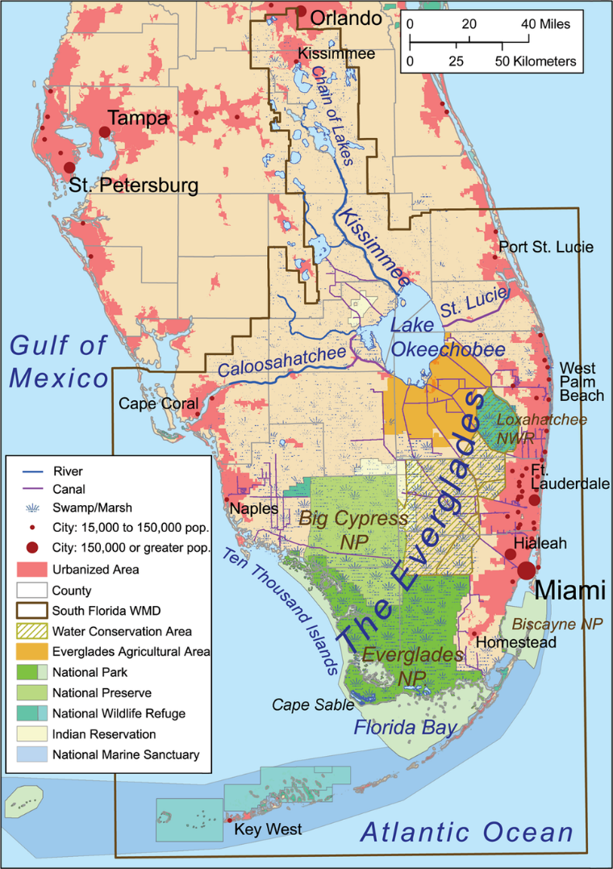

Governor Rick Scott issued an emergency order in seven counties in July, but Florida city mayors and congressional representatives are seeking additional financial aid from the Federal Emergency Management Agency (FEMA) to combat these toxic algal blooms. If warming oceans and increasingly intense storms foster more persistent red tide episodes, more than a one-time financial intervention may be necessary to resolve this environmental crisis.

